Specification sheet for free standing 50inch IR touch Kiosk— 4K monitor
Product Overview 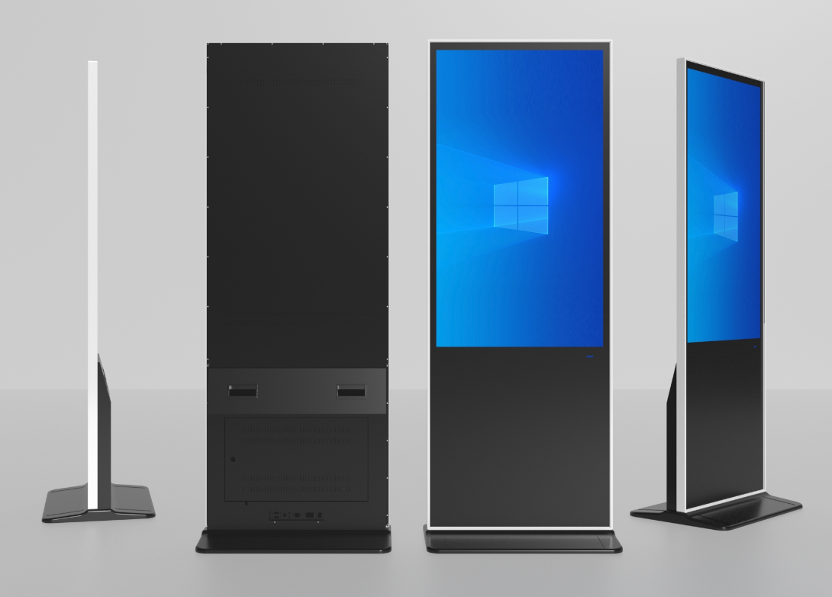
- Appearance: Industrial-grade structural design concept, one-piece frame, thin and beautiful body, simple installation and convenient maintenance, unique heat dissipation technology, can support 7*24 hours of work
- High-definition: Using IPS high-definition LCD panel, it has gorgeous colors, high brightness, supports up to 1080P video and picture decoding and playback, and can achieve high-quality picture output display.
- Intelligence: Equipped with an intelligent Windows operating system, it has rich interfaces, can install client third-party software, is simple to operate, and has powerful functions to meet diversified usage needs.
- Touch control: Using a high-precision infrared optical touch solution, the touch is precise, the writing is smooth, the response is fast, and the anti-interference is strong. It can support up to 20 points of touch.
- High-end: It is widely used in government and enterprise, medical, finance, education, transportation, supermarkets, multimedia exhibition halls and other scenarios that require touch inquiry and intelligent interaction. It is an intelligent high-end touch all-in-one machine

Display parameters
LCD grade | Fully new A+LCD panel
Panel size | 50inch
Resolution | 3840*2160
Viewing angle | 89/89/89/89
Display area | 1096*616mm
Display ratio | 16:9
Backlight type | E-LED
Screen brightness | ≥400cd/m2（Typical value）
Refresh frequency | 60HZ
Color support | 16.7M(8-bit)

Touch parameters
Touch solution | Non-contact infrared sensing technology
Touch lifetime | ＞50000 hours
Touching points | 10 points (as default)
Touch surface | 3mm tempered glass(Physically tempered Mohs level 7 explosion-proof, anti-glare, etching requires special customization）
Response time | Single point mode: click 8ms, continuous 3ms  Multipoint mode: click 8ms, continuous 5-8ms
Touching precision | ≦2mm
Touching mode | Finger or stylus
Output mode | coordinate
Anti-light properties | incandescent lamp (220V,100W)，The illuminance of sunlight reaches 90000Lux when the vertical distance is more than 350mm.
driver | USB free drive
Calibration mode | Manufacturer's special calibration software (please do not use the calibration software that comes with Windows, as it may cause inaccurate touch)

Monitor parameters
Model of mainboard | BSD-TK3
interface | HDMI 1pc、USB 1pc
Speaker power | （8Ω）2 X 10W

Body parameters
Optional color | Black surface silvery frame/completely black
Frame material | Aluminum profile (oxidized wire drawing)
Body material | Hardware cold-rolled steel plate (metal spraying)
Surface material | 3mm tempered glass (physical tempering)
Body size | 1856.8*684.9*38mm
Packing dimension | 1900*805*160mm
Packaging material | Neutral thickened carton
N.W. | 48.6KG
G.W. | 55.2KG
Installation mode | Free standng（vertical）

Electrical performance
Applicable scenarios | indoors
Rated voltage | AC110-220V
Standby power | ≦1W
Rated power | ≦150W
Usage environment | Temperature:‐0℃~55℃/humidity: 10%RH~90%RH
Storage temperature | Temperature:‐5℃~60℃/humidity:10%RH~90%RH

Packing List
Overall machine | 1 unit
Power cord | 1 pc
WiFi antenna | 1 pc
Warranty card/  certificate of conformity | 1 pc

Dimensional drawing


